


Module 4 - The Senses
This Module explores how our different senses can be used to convey the same information. Sections within this Module include the use of hearing, touch and smell to identify objects in place of sight, the importance of Mathematics in calculating distances without sight and how our understanding of other senses changes as vision decreases.

The following information has been drawn from the Curriculum Framework document and associated Curriculum Guidelines to help teachers place the module in context.

SCIENCE LEARNING AREA STATEMENTS
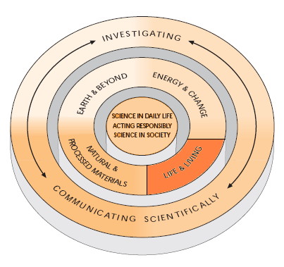

INVESTIGATING

Students investigate to answer questions about the natural and technological world using reflection and analysis to prepare a plan; to collect process and interpret data; to communicate conclusions; and to evaluate their plan, procedures and findings.

LIFE AND LIVING
….Students understand their own biology and that of other living things, and recognise the interdependence of life…

….Students understand the relationship between structure and function in living things and use that as a basis for understanding life-maintaining processes….

…They identify the characteristics of living and non-living things. They recognise themselves as living things and give examples of their needs and the characteristics that identify them as living…

….Students describe how living things function as whole organisms and explain the relationship between structure and function in systems, organs, tissues and cell....

...They know about the effects of disease and how to maintain a healthy lifestyle…..

MATHEMATIC LEARNING AREA STATEMENTS

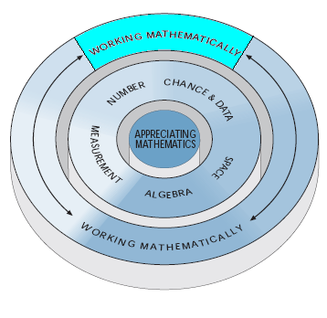
WORKING MATHEMATICALLY
….Students call on a repertoire of general problem solving techniques, appropriate technology and personal and collaborative management strategies when working mathematically….

….Students draw on a range of general strategies when dealing with mathematical problems to which they have no readily available method of solution….

…Students identify and attempt subtasks; generate and systematically list possibilities; and eliminate possibilities. They make thoughtful use of technology to enhance their mathematical work….

But they also recognise the value of working with others, cooperating to pool ideas and welcoming, and dealing constructively with, conflicting perspectives and views.

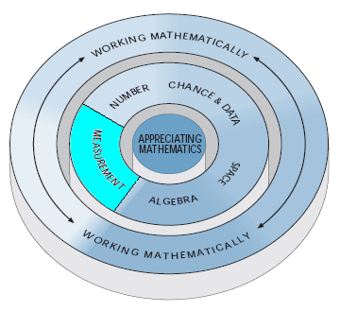
MEASUREMENT
….Make sensible direct and indirect estimates of quantities and are alert to the reasonableness of measurements and results….

….Students have a good idea of the size of common standard units, make sensible estimates with them, and have the disposition and skills to judge the reasonableness of estimates and measurements…

….Students also reason from known and collected quantities to estimate quantities which cannot be found directly or conveniently:

